**“TEMPERATURE CONTROLLED FAN USING ARDUINO”**

**PROJRCT REPORT**

**TABLE OF CONTENTS**

|  |  |  |
| --- | --- | --- |
| **SNO** | **CONTENT** | **PAGE NO** |
| 1 | Abstract | **3** |
| 2 | Introduction | **4** |
| 3 | Components | **5** |
| 4 | Circuit Diagram | **6** |
| 5 | Working | **7** |
| 6 | Advantages/Disadvantages | **8** |
| 7 | Applications | **9** |
| 8 | Conclusion | **10** |

**ABSTRACT**

Humanity is currently advancing toward new technologies by replacing manual processes with automatically controlled gadgets. A cooling fan is one of the most fundamental needs of humans in hot weather. However, the fan's speed may be adjusted manually using a manual switch known as a fan regulator or dimmer. The fan speed may be adjusted by adjusting the dimmer. It may be observed in some regions, such as if the temperature is high in the morning but drops dramatically at night. The users do not grasp the temperature difference. So, to overcome the fan's speed here's a temperature-dependent approach.

**INTRODUCTION**

The temperature-based fan speed control system can be done by using an electronic circuit using an Arduino board. Now Arduino board is very progressive among all electronic circuits, thus we employed Arduino board for fan speed .The proposed system is designed to detect the temperature of the room and send that information to the Arduino board. Then the Arduino board executes the contrast of current temperature and set temperature based on the inbuilt program of the Arduino. The outcome obtained from the operation is given through the o/p port of an Arduino board to the LCD display of related data. The generated pulses from the board which is further fed to the driver circuit to get the preferred output to the fan.

ARDUINO micro controller is the heart of the circuit

as it controls all the functions. The temperature sensor DHT11

senses the temperature and converts it into an electrical

(analog) signal, which is applied to the Arduino. The

sensed and set values of the temperature are displayed on the

16x2-line LCD

**COMPONENTS:**

1. Arduino
2. USB Cable
3. DHT11 temperature sensor
4. LCD DISPLAY
5. Jumper wires
6. Bread Board
7. An AC FAN
8. POTENTIOMETRE

**CIRCUIT DIAGRAM**

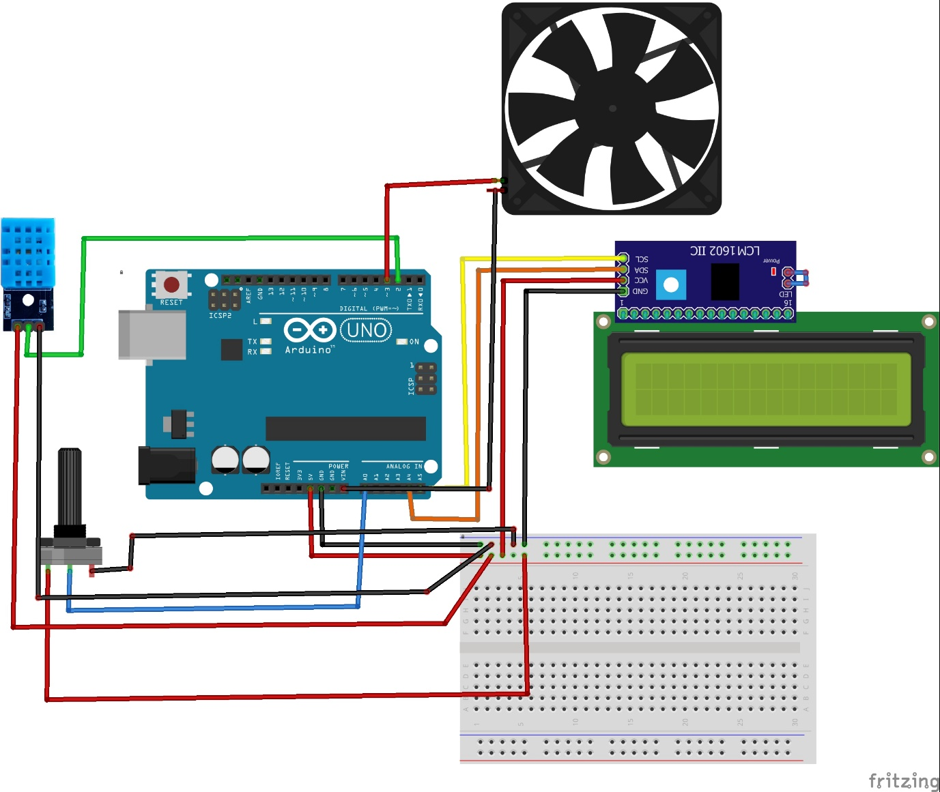

**WORKING**

The DHT11 sensor is interfaced with the Arduino UNO. The DHT11 sensor has 3 pins VCC, data and GND. VCC is connected to 5v pin of Arduino and GND is connected to gnd pin of Arduino which are connected to bread board. And the data pin is connected to A3 pin of Arduino which is digital input pin.

The described project is a temperature control system that utilizes an DHT11 temperature sensor, an Arduino microcontroller, and a potentiometer to regulate AC fan.

The DHT11sensor provides the temperature data, which is received by the Arduino. The Arduino process the data and sends the corresponding output to the LCD module for display. The Arduino continuously reads the sensor data, updates it and displays the current surrounding temperature on LCD in real time. An ac fan is interfaced to Arduino to A3 pin. Fan rotates according to the surrounding temperature. If the temperature value is greater than threshold the fan start to rotate. If the temperature is less than threshold the fan pin will be off. We can change the value of threshold by using potentiometer. We can operate the fan by using this potentiometer. The value of threshold and surrounding temperature values are displayed on the LCD display.

With the help of temperature sensor we can know the surrounding temperature at instant time and display it on LCD according to the temperature value the fan will rotate if we keep the threshold value less than that of temperature value that is obtained.

**ADVANTAGES**

1. This project can be used in Home.

2. This project can be used in Industry.

3. This will help in saving the energy / electricity.

4. To monitor the environments that is not comfortable, or

possible, for humans to monitor, especially for extended

periods of time.

5. Prevents waste of energy when it’s not hot enough for a fan

to be needed.

6. To assist people who are disabled to adjust the fan speed

automatically.

**APPLICATIONS**

1.Temperature based fan speed controller is useful for cooling the processor in the laptops and personal computers “more efficiently”. Generally fan in laptop comes with only two or three possible speeds. So it results in more power consumption.

2.The fan designed in this project, has different values of speed according to temperature change. This can be also used in small scale industries for cooling the electrical/mechanical equipment. The whole circuit except motor and fan can be manufactured on a single PCB, and it can be used for temperature based control operations.

**CONCLUSION**

The temperature controlled fan mini project employing the Arduino uno,DHT11 sensor, potentiometer and IIc backlight 16x2 LCD module offers accessible solution for easy usage of fan controlling according to the surrounding temperature. As this circuit is designed as a prototype. This can be further modified into better version of it. By this project we control the fan according to the surrounding temperature.